🧩 Maven Jenkins CI/CD Project Summary
This repository demonstrates a complete CI/CD pipeline using Jenkins, Maven, and Docker, created for educational purposes on Shubham Gour’s YouTube channel.
📦 Project Repository:
👉 https://github.com/theshubhamgour/maven-jenkins-cicd-demo

🚀 What This Project Covers
- Build Automation: Maven used to compile and package a Java application
- Unit Testing: JUnit for automated testing integrated within Jenkins
- Dockerization: Application is containerized with Docker
- Image Deployment: Jenkins pushes the Docker image to DockerHub
- Pipeline Automation: A multi-stage Jenkinsfile handles everything — from build to deploy

⚙️ Jenkins Pipeline Stages
- 🧹 Clean Workspace — Remove old files
- 🏗️ Build — Compile Java code
- 🧪 Test — Run JUnit tests and publish results
- 📦 Package — Create executable JAR
- 🔍 Static Code Analysis — Quality check (optional)
- 🐳 Docker Build — Build Docker image
- 🔐 Login to DockerHub
- 🚀 Push Image — Upload image to DockerHub
- ⚙️ Deploy Container — Run the built container
- 🧾 Post-Deployment Check — Validate the app
- 🧼 Cleanup — Stop and remove containers/images

🧰 Technologies Used
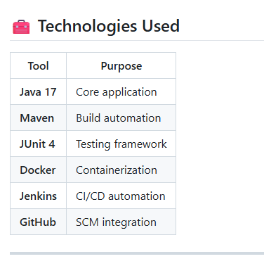
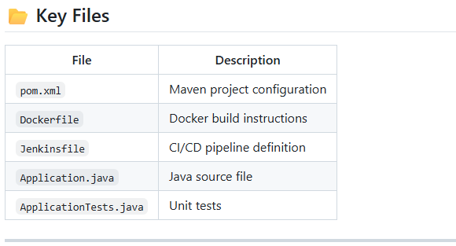

🎥 Tutorial Reference
Watch the full step-by-step tutorial on YouTube:
👉 #theshubhamgour

🧾 Author
Created by: Shubham Gour
Project Link: https://github.com/theshubhamgour/maven-jenkins-cicd-demo
💡 Follow for more DevOps tutorials and hands-on CI/CD projects.

